CED Talk | Owen Valley High School
Preparing & Presenting Your CED Talk

Welcome!
Thank you for showing interest in giving a CED Talk for the students at our very own Owen Valley High School. In this document, you will find everything you need to know about preparing & presenting your CED Talk, and by the end you should be nothing short of a CED Talk professional! We are glad to have you on board with the program, and we are sure you will knock it out of the park. Happy planning!
Index
- What is a CED Talk?
- Brainstorm & Choose Your Topic.
- Outline & Script Your CED Talk.
- Make Your Slideshow.
- Practice! Practice! Practice!
- Take the Stage.
- Pat Yourself on the Back. You’re Done!

To see visit the Website, click here.

- What is a CED Talk?
- The What -
The inspiration for our CED Talks at Owen Valley High School stems from the world-renowned TED Talks. If you have not seen a TED Talk before, we highly recommend that you watch one to aid you in your development. These CED Talks, in short, are presentations designed to deliver ideas and concepts in a short, comprehensive manner to the students at Owen Valley High School, and you are the person who is going to deliver that message.
- The Why -
Students are going to be the next group of people to enter the workforce much like many of us had when we left school. In that time, we all probably have at least one moment that got our gears turning regarding what were inspired to pursue in the future. These CED Talks (i.e., your ideas and story) are hopefully going to be that for students!
- The How -
With the CED Talks being a part of these students’ lunch periods, it is important that we emphasize the short & comprehensive aspect of the talk. You have exactly 20min of stage time before it’s curtains, meaning you have to make as much of your time valuable as possible. You will have 15min to present, and then 5min of Q&A; therefore, your talk should be no less than 10min but no more than 15min. Even though it feels like a lot of time, 10-15min can fly by when you’re having fun (or sweating through your shirt), so make sure your CED Talk fits within those bounds.

- Brainstorm & Choose Your Topic.
- What Should My CED Talk Be About? -
This is your CED Talk, and you can give it on, dare we say, whatever it is that you feel is worth presenting to inspire these students. Before any final decisions are to be made about what you are presenting, you have some questions to ask yourself. These range anywhere from anything as specific as “What aspect of my career is unique enough that would interest students?” to something as easy as “What would I have wanted to hear in high school?”.
You have complete creative liberty on your talks (so long as it adheres to school guidelines!), so take that opportunity to explore what you have to offer.

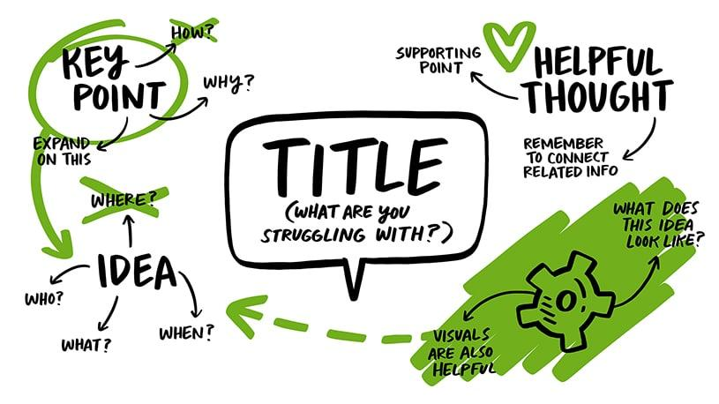
Taken from https://inkfactorystudio.com/blog/visual-brainstorming-techniques/
- Am I Ready? -
Once you have narrowed down your brainstorming to one or two topics, write them out in front of you. Ask yourself questions like: Has this already been presented? Would I want to listen to this? Can I feasibly provide solid information about this idea? If all your answers are yes, then your answer to “Am I Ready?” is a yes as well! Now that you have your topic, it is time to start planning the CED Talk.
- Outline & Script Your CED Talk.
- The Outline -
Depending on your profession, the last time you may have had to speak in front of a group of high school students may have been your very own high school speech class. Getting (and keeping) the student’s attention is important, and the following structure should help you in doing just that.
- Grab the audience attention. Use a personal anecdote or a quote to spark curiosity.
- Hash out the meat and potatoes. Present your idea to the audience to the best of your ability. Be confident!
- Provide any evidence or supporting ideas that back up your idea.
- Bring it home. Create a personal attachment to the audience or bring it back to the hook you used in step 1.
While this structure is relatively basic, it is effective in what it does as to deliver the message to your audience. That being said, if you feel confident that you have a better structure that makes you feel more confident, feel free to use it, but make sure that you always are conveying the main idea in whatever method you use.
- The Script -
Once you have your outline done, start writing down what you are going to say in your presentation. Write confidently and speak in a way that feels best to you. A script should be rehearsed word for word, but that does not mean missing a word in the presentation is the end of the world. This is to get your brain accustomed to what direction you will be going in your CED Talk, and it will make you more comfortable in the long run.
4. Make Your Slideshow.
- The Slides -
Slides help your audience visualize what it is you are trying to convey in your CED Talk, but by no means feel like you need to slap your script onto a Microsoft PowerPoint. Your slides should be only filled with basic talking points, visuals, or data that would augment what you are saying.
Remember one thing: If the audience is busy reading, they will not be busy listening. You are the focal point of the CED Talk, and slides should only be an extension of you rather than the main show.

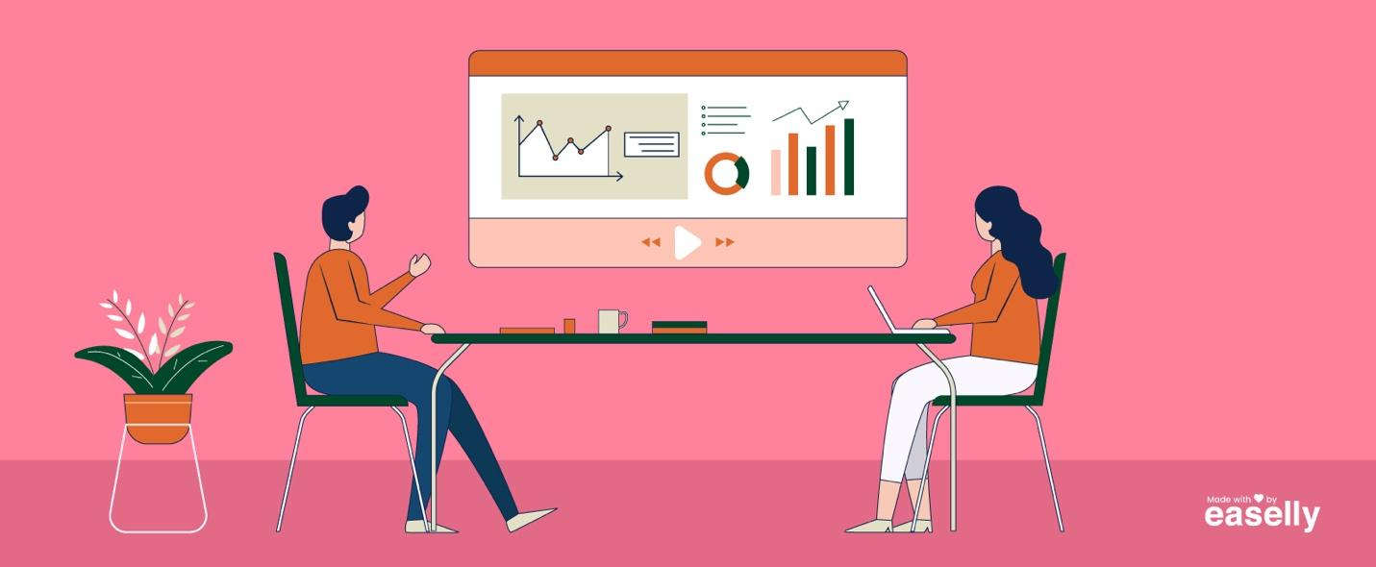
Taken from https://www.easel.ly/blog/infographics-visual-aids-presentation/

5. Practice! Practice! Practice!
- Rehearse -
You didn’t write the script for no reason! Once your CED Talk is all ready to go, start rehearsing your lines like a well-seasoned Broadway star. Ask friends, family, coworkers, and anyone else you can find to be your audience until your nerves are calm and you feel 100% secure. We promise that better rehearsal means better performance, and you will thank yourself in the end!
- Record & Rewind -
We know you won’t like this one, but hear us out when we say to record yourself giving your CED Talk. While most of us hate the sound of our own voice, watching and hearing yourself on tape can show you exactly where it is that you struggle in your presentation. Once you have taken note of those trouble spots, go back and record again to see if you improve. I guarantee you will see some improvement!
Rehearsing also provides you with the opportunity to test that very important short & comprehensible bit from earlier. Keep note of your average time from recording. If it regularly falls between that 10-15min window, you’re doing great.
6. Take the Stage.
- Presenting Your CED Talk -
…Need we say more? You are ready and going to do great!
- Q&A -
You’re in the home stretch at this point. The minimum of a 5min Q&A can seem somewhat daunting, but just remember that this is you and a group of high school students, not an interrogation by the CIA. You know the information on the topic, and these students will trust your answers. You just have to trust yourself that you know them.
If you are still nervous about this portion, you can always create a list of anticipated questions. Think about what you think the students will ask, and then create a list of questions and 3-5 sentence answers to each. You’ve got this!
7. Pat Yourself on the Back. You’re Done!

